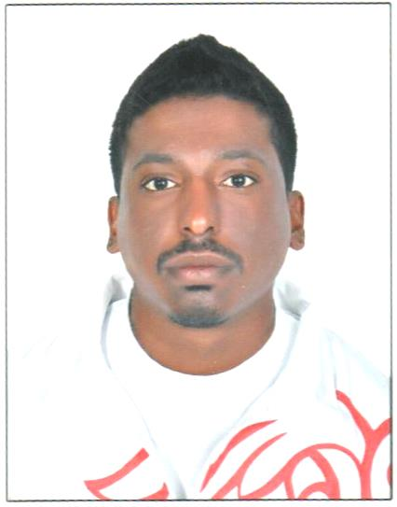
CURRICULUM VITA

ABDUL RAHMAN KHALED ABDULLA ALSENDI
Mobile No: +973-33316411
CPR: 920404839

OBJECTIVE

To work a challenging friendly offering job satisfaction where my exposure skill can be used in the best possible way give me an opportunity to my career development.

EDUCATIONAL QUALIFICATION

- Secondary School Leaving Certificate
- Higher secondary

EXPERIENCE

- Worked AS A Security in Formula 1 Bahrain 7 years
Strengths

- Positive Attitude
- Time keeping & Self confidence
- Active & Hard-working mind

Personal Profile

- Father Name : Khaled
- Date of Birth : 13/04/1992
- Gender : Male
- Nationality : Bahraini
- Languages know : Arabic, English, Spanish & French
- Marital status : Single

Driving license

- DRIVING LICENCE Private
- DRIVING LICENCE Private Transport
- DRIVING LICENCE Special Use

Personal Profile

References will be furnished upon Demand

I hereby declare that all the above information is true and correct to the best of my knowledge and belief.

THANK YOU

ABDUL RAHMAN KHALED ABDULLA ALSENDI

